**Part 2: Design Alternatives - GATAL AND HAO**

**Scenario:**

Scenario 1 - Shiro always forgets which E-wallet she used for a transaction. Because of this, she often forgets the monthly subscriptions of her content creation tools which caused her to lose access to the exclusive features.

Scenario 2 - Alex, who uses multiple online wallets, is on a shopping spree and keeps on using the tap-to-pay feature on his phone. At the end of the day Alex is unsure of which wallets were used in his shopping spree.

**Storyboard (Based on Scenarios):**

**Scenario 1**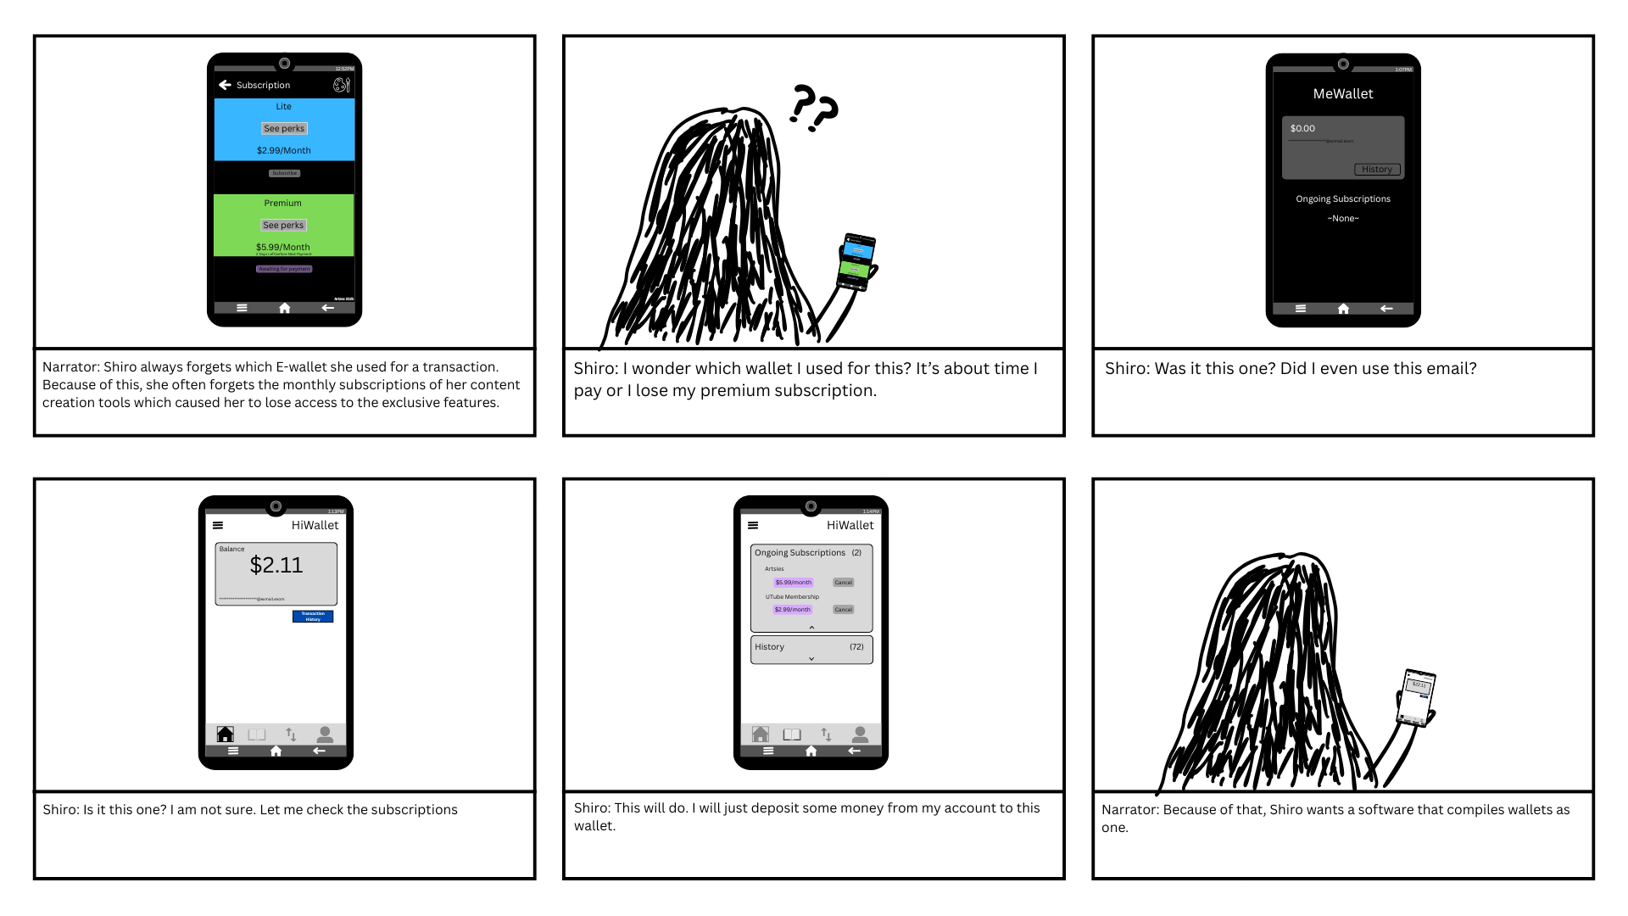

**Scenario 2**

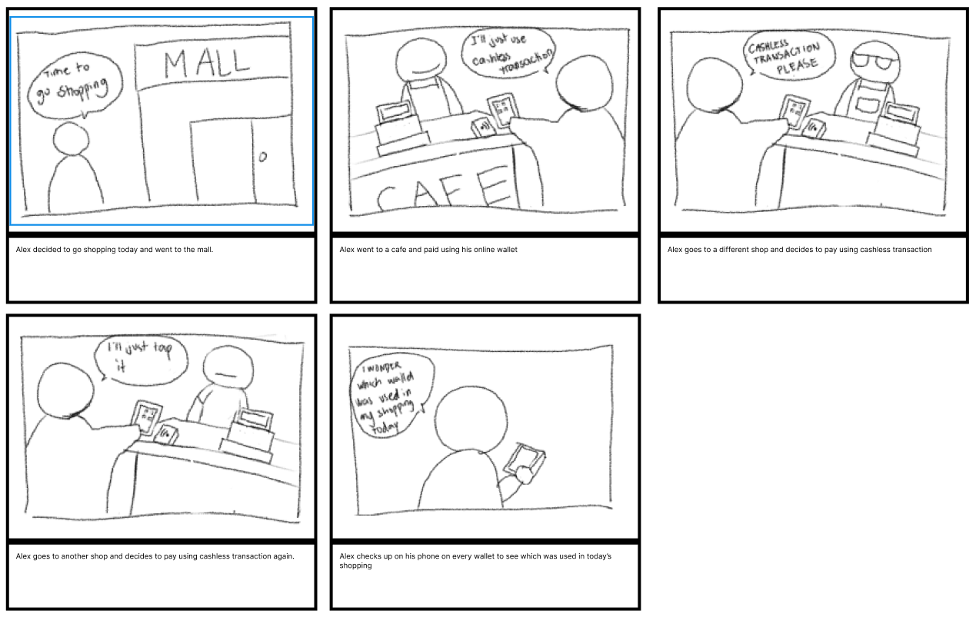

**Problem Statement:**

● **NFC Android users not getting properly notified**

● **NFC Android users doesn’t have a central app to view all their transactions**

**Application Icon Size comparison**

The icons above showcase the application icon in various sizes. This is essential to identify how it would look in many different screen ratios.

|  |  |
| --- | --- |
| 36px x 36px |  |
| 72px x 72px |  |
| 96px X 96px |  |
| 144px X 144px |  |
| 192px x 192px |  |

**Design**

The TTTAPP application aims to showcase a modern-stylistic design. In order to achieve this design, the following will be identified: Color Palette, Font Style, and GUI.

**Color Palettes**

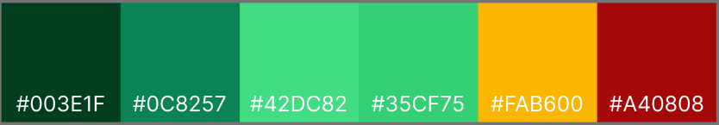

**Font Style**

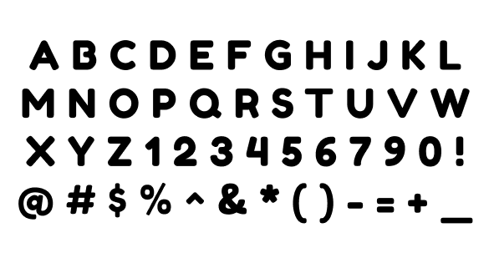

The pair has chosen to use the Fredoka One font for the application due to its simplicity and lack of reliance on overly decorative design. It is the simple yet well suited to the application that the pair is drawn to.

**GUI**

The pair will only be using the Android GUI for the application so to not complicate matters by adopting 2 separate GUI designs for different models. The pair will be adopting the Android GUI from Figma for this application.

**Sample Feature Flows**

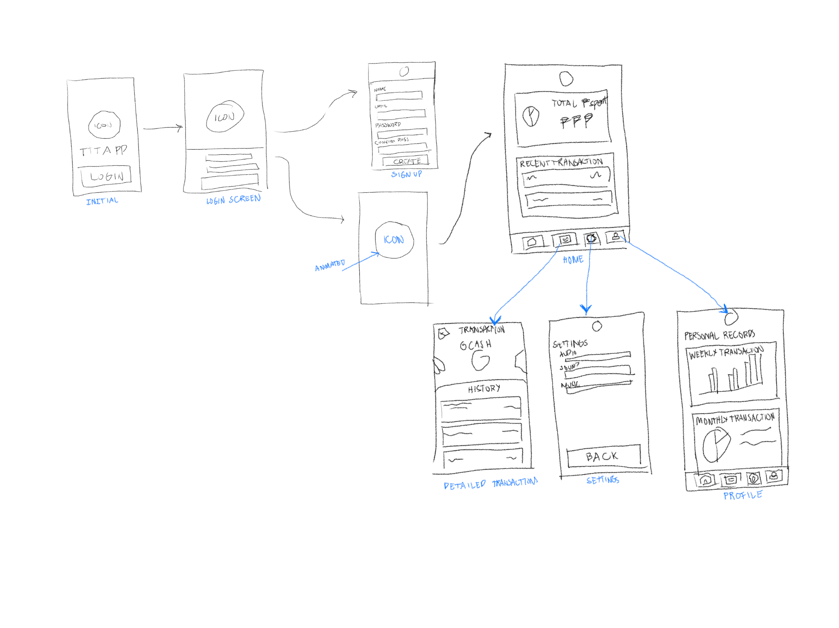

**DESIGN CONCEPT**

The pair has created a series of alternative designs intended for use in the application. These designs are not yet finalized and will undergo testing once proper prototyping begins.

|  |  |  |  |
| --- | --- | --- | --- |
| SKETCH | WIREFRAME | PROTOTYPE |  |
|  |  |  | This is the initial screen of the app when the user has not yet logged in. |
|  |  |  | This is the login screen where the user inputs their credentials and has options for signing up and recovering their accounts. |
|  |  |  | This is the register page where the user could create a new account by inputting their information. |
|  |  |  | This is a transition/loading screen which will be used for transitioning between screens. |
|  |  |  | This is the homepage where it displays quick informations about the user’s recent actions |
|  |  |  | This is the detailed transaction list where the user can view their transactions on a specific NFC wallet |
|  |  |  | This is the settings where users can tweak to their preference |
|  |  |  | This is the Profile tab where users can see their overall datas and also where users would connect their wallets. |

**Additional Feature Discussion**

The pair has conducted a survey for the application but has not yet reached a minimum of 10 respondents. Therefore, they will limit their discussion to the suggestions provided by the current number of respondents.

**Suggestion-Notification**

The pair would like to address this concern by implementing frequent notifications to help users stay on track and avoid pacing issues. They have also created a sketch to illustrate this suggestion.

|  |  |
| --- | --- |
|  |  |